PV solar optimal MPPT under shading

Arifin. Arif
Abdul Rafae Mohammed |#0874505 |amohammed4505@mytu.tuskegee.edu
Walid Misbah
Date:12th December 2016

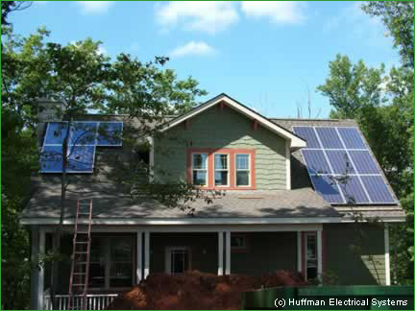
1 SOURCE: http://www.altenergystocks.com/archives/policy/

TABLE OF CONTENTS

INTRODUCTION 3
SHADING 4
EFFECTS OF SHADING 5
IMPLEMENTATION 6
REFERENCES 8

INTRODUCTION

Our world today is on the verge of an energy crisis. As the conventional resources getting depleted day by day, we are coming closer and closer to a situation where we would not have enough supply of energy to meet our daily needs. The only way is as we know to shift for an alternate energy source. Although we have identified and addressed this issue to an extent but results have not been proven very economical and sustainable.
The Conventional Energy Sources are exhausting at an alarming rate.So there is an urgent and strong need to move towards the Non-Conventional Energy Sources.One of the Most abundantly available energy resource is Solar Energy.Over the recent years, efforts have gone into tapping this energy source using the solar cells and has been one of the major contributors towards the renewable energy production. But, these solar cells are vulnerable and hence their efficiency of energy production can be hampered due to factors like shading, Manufacturing defects , etc.

The aim of this project is to tackle the problem of shading in solar cells.

SHADING

Shading is phenomenon due to which the sunlight is obstructed from falling on the solar cells and hence reducing the Power Output considerably.

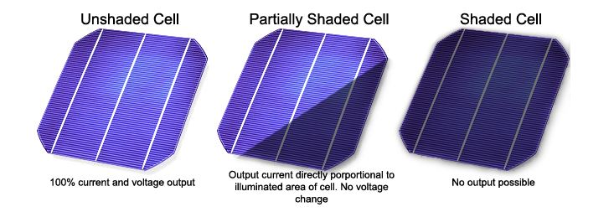
Fig:1:Shading of a Solar Panel
Source:http://sargosis.com/how-shade-affects-a-solar-array/

Shading can be of 2 types:
a) Soft Shading –Partial Blocking of sunlight due clouds.
b) Hard Shading – Physically Obstructing the solar cell by a tree,etc.

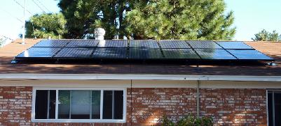

Fig:2:Shading of a Solar Panel due to Tree

Source: http://www.reuk.co.uk/wordpress/solar/effects-of-shading-on-solar-panels/
EFFECTS OF SHADING

Consequences of shading on a PV Array are destructive. Shading on even one cell in a string having ‘n’ cells is series drastically the current almost to half and thereby affecting the power output of that array. Here in the below graph we can see how the current comes down to half and this inturn affects the power output of the solar array. Here the power output is reduced by half of the normal PV array output. Another issue which shading carries with itself is the occurrence of multiple maximum power points which can be seen by the multiple peaks observed in power-voltage graph. These multiple points pose problem while doing maximum power point tracking. Due to these multiple peaks we often end up at local maxima instead of global maximum.

IV Graph PV Graph
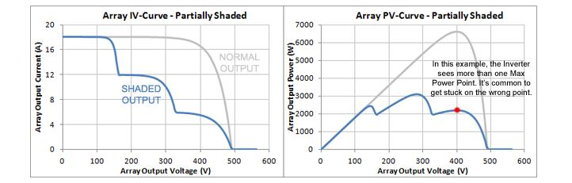
Fig:2: I-V and P-V Characteristics of a shaded PV Cell

SOURCE: http://sargosis.com/how-shade-affects-a-solar-array/

IMPPLEMENTATION

Many methods have been implemented to solve this problem of shading and some improvements have been seen . This problem can be solved to an extent by reconfiguring the solar array. Some of the few methods which have been implemented are:
- TCT Configuration
- Su Do Ku Configuration
- Genetic Algorithm

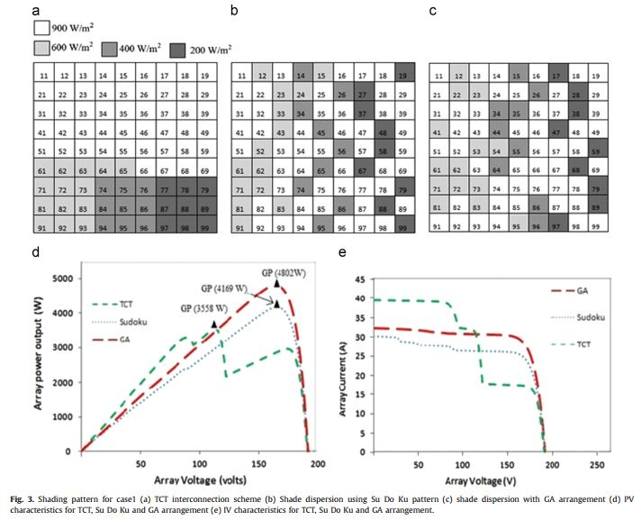
Fig 3: I-V and P-V Characteristics of solar PV array after reconfiguration

Source :http://www.sciencedirect.com/science/article/pii/S136403211400923X

The above 3 methods were implemented and following were the observations.[1]
Initially the Solar PV array is configured in TCT Configuration and the power output is observed and multiple output peaks are observed along with drop in output power. The output power is calculated by multiplying the array voltage with the total output current of the pv array. Since the row having the lowest current dominates the complete arrays output current , we need to bypass the rows in the ascending order of the lowest row current to track the maximum power point . As expected multiple peaks were observed and in many occasions we ended up at a local maximum while performing maximum power point tracking. Then the array is reconfigured in So Do Ku Configuration and the process was repeated. There was significant improvement in the power output of the solar array and we did not see any multiple peaks. Then the pv array was reconfigured again by using the genetic algorithm and the results were even better that Su Do Ku Configuration . Fig: 3 shows the 3 configurations and the power output respectively.

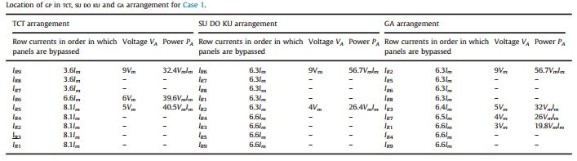
Fig 4: Analysis and Comparision of the 3 Configuration Methods

Source : http://www.sciencedirect.com/science/article/pii/S136403211400923X

Fig: 4 shows how the MPPT was performed and the order in which the rows were bypassed.

REFERENCES

[1] Shubhankar Niranjan Deshkar et al., “Solar PV array reconfiguration under partial shading conditions for maximum power extraction using genetic algorithm,” Renewable and Sustainable Energy Reviews 43 (2015): 102–110

Fig 1 :http://sargosis.com/how-shade-affects-a-solar-array/

Fig 2 : Source: http://www.reuk.co.uk/wordpress/solar/effects-of-shading-on-solar-panels/

Fig 3,4 &5 : Shubhankar Niranjan Deshkar et al., “Solar PV array reconfiguration under partial shading conditions for maximum power extraction using genetic algorithm,” Renewable and Sustainable Energy Reviews 43 (2015): 102–110

